**DEPARTMENT OF ELECTRICAL AND COMPUTER ENGINEERING**

Design Document for

**KIDGUARD**

Submitted to:

Timothy Sellers

ECE 4522: Senior Design II

Department of Electrical and Computer Engineering

413 Hardy Road, Box 9571

Mississippi State University

Mississippi State, Mississippi 39762

December 6, 2024

Prepared by:  
L. Baker, E. Howell, J. Lee, M. Pickering, H. Zheng

Faculty Advisor: Professor Yu Luo

Department of Electrical Engineering and Computer Engineering

Mississippi State University

413 Hardy Road, Box 9571

Mississippi State, Mississippi 39762

Email: {lwb139, erh297, jal807, [mpp171}@msstate.edu](mailto:mpp171%7d@msstate.edu)

# **LIST OF ABBREVIATIONS**

API – Application Programming Interface

°C – Celsius

°F – Fahrenheit

FMVSS – Federal Motor Vehicle Safety Standard

IEEE – Institute of Electrical and Electronics Engineers

IT – Information Technology

KG:S – KidGuard: Sidekick

LCD – Liquid Crystal Display

LED – Light Emitted Diode

LoRa – Long Range

MAC – Medium Access Control

PHY – Physical Layer

SMS – Short Message Service

TEDS – Transducer Electronic Data Sheet

V – Volts

**EXECUTIVE SUMMARY**

The main priority for KidGuard is ensuring children's safety through reliable battery performance and consistent data transfer. The temperature and weight sensors are designed to withstand extreme temperatures in vehicles. KidGuard’s universal and intuitive design allows users to employ the device in any car seat they own. Accurate and reliable data is sent to the user’s communication device, KidGuard Sidekick (KG:S) ensuring the user is always knowledgeable about their child’s safety. The 10 to 15 hours of continuous battery life guarantees the user is aware of the conditions inside the vehicle. KidGuard’s innovative attachment to car seats follows the Federal Motor Vehicle Safety Standard No. 213 and does not inhibit the functionality of the car seat.

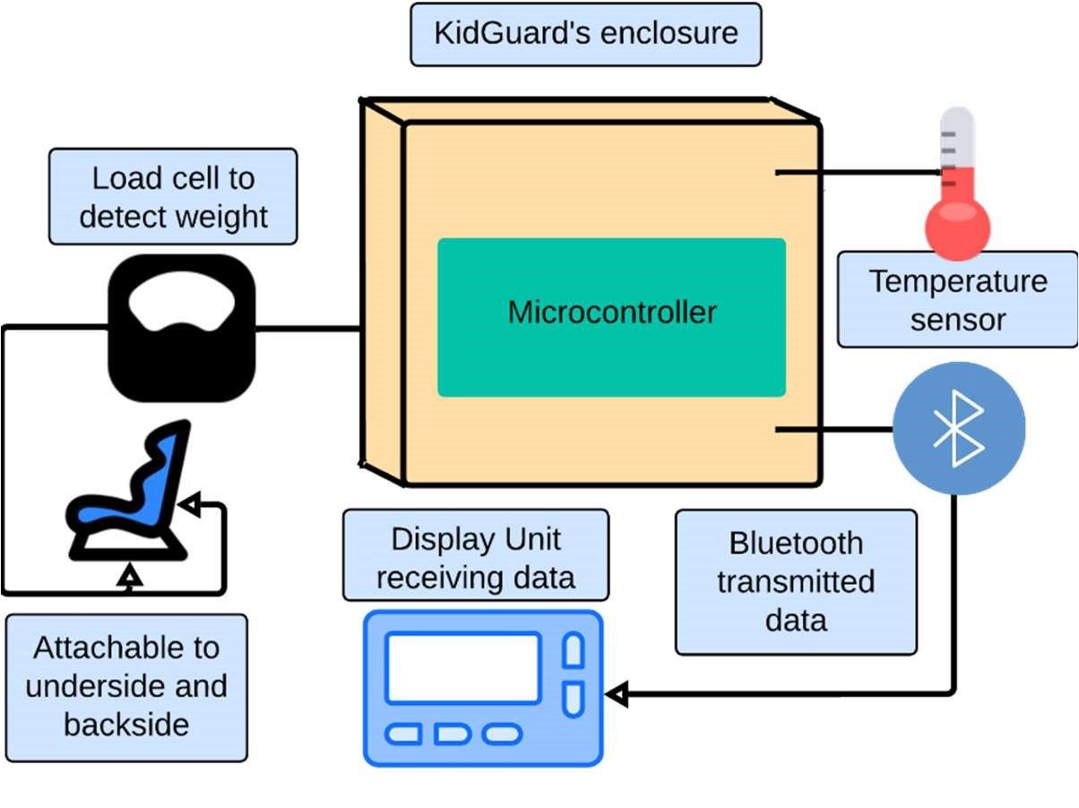

# **Fig. 1: KidGuard Overview**

The goal of KidGuard is to ensure the safest, fail-proof climate monitoring device by using weight detection, thermal sensing, and wireless communication. KidGuard utilizes four load cells to detect the presence of a child in a car seat, and a thermal sensor to monitor the ambient temperature inside the vehicle. This data is relayed to the user with a Bluetooth communication system. As a parent leaves the vehicle, they receive an alert on their communication device that a child has been left behind. KidGuard actively monitors the interior conditions and alerts the parent once the conditions encroach on being unsafe. If the vehicle’s interior exceeds 86°F (30°C) for more than five minutes, another alert is sent to the parent. The recurring notifications allow the user to be up to date on their child’s safety.

KidGuard currently works for all car seats, but making KidGuard universally compatible with booster seats could improve its usability across age ranges. Another consideration is ensuring that KidGuard operates under freezing conditions. Furthermore, KidGuard includes insulation to protect against some cold. However, in areas where the weather is often below freezing, it might need additional functionality to operate correctly.

**TABLE OF CONTENTS**

**1. DESIGN REQUIREMENT SPECIFICATIONS6**

**1.1. Requirements6**

**1.1.1. Marketing Requirements6**

**1.1.2. Engineering Requirements7**

**1.2. Constraints8**

**1.3. Standards8**

**2. DESIGN APPROACH9**

**2.1. Design Options9**

**2.1.1. Design Option 19**

**2.1.2. Design Option 29**

**2.1.3. Design Option 310**

**2.2. System Overview10**

**2.2.1. Microcontroller12**

**2.3. Subsystems13**

**2.3.1. Bluetooth14**

**2.3.2. Temperature15**

**2.3.3. Weight Detection16**

**2.4. Level 2 Prototype Diagram18**

**2.4.1. Level 2 Diagram18**

**3. EVALUATION20**

**3.1. Test Certification – Sound Buzzer20**

**3.2. Test Certification – LEDs20**

**3.3. Test Certification – Power21**

**3.4. Test Certification – Temperature Range21**

**3.5. Test Certification – Weight Sensor22**

**4. SUMMARY AND FUTURE WORK22**

**5. BUSINESS PLAN22**

**5.1. Objectives22**

**5.2. Keys to Success22**

**5.3. Plan Overview22**

**5.3.1. Mission23**

**5.3.2. Objectives23**

**5.3.3. Keys to Success23**

**5.3.4. Competitive Advantage23**

**5.3.5. Target Market23**

**5.3.6. Basic Strategies23**

**5.4. Company Summary24**

**5.4.1. Company Description24**

**5.4.2. Company Location and Facilities24**

**5.4.3. Company Strategy24**

**5.4.4. Startup Costs24**

**5.5. Product Summary25**

**5.5.1. Product Description25**

**5.5.2. Customer Needs and Benefits25**

**5.5.3. Future Products25**

**5.5.4. Manufacturing and Distribution Strategy26**

**5.6. Market Summary26**

**5.6.1. Marketing Analysis26**

**5.6.2. Marketing Strategy26**

**5.6.3. Sales Projection26**

**5.6.4. Manufacturing and Distribution Strategy26**

**5.7. Organization Overview27**

**5.7.1. Company Structure27**

**5.7.2. Personnel Plan27**

**5.8. Financial Plan28**

**5.8.1. Profit and Loss28**

**5.8.2. Projected Cash Flow28**

**5.8.3. Projected Balance Sheet29**

**6. DESIGN II UPDATES30**

**7. ACKNOWLEDGEMENTS30**

**8. REFERENCES31**

**1. DESIGN REQUIREMENT SPECIFICATIONS**

KidGuard is a solution to a guardian’s nightmare, harm to a child. KidGuard is designed with children’s safety in mind. The device attaches to the underseat and is engineered to alert guardians that a child has been left in a car and that the conditions inside are unsafe. KidGuard’s marketing requirements, engineering requirements, constraints, and standards are detailed in the following sections.

**1.1. Requirements**

KidGuard detects a child in the car seat using weight detection and monitors the interior temperature of the vehicle. This device alerts the user that the child is in the vehicle.

Furthermore, the user is notified of the temperature upon leaving the vehicle and until the user acknowledges the notification.

* + 1. **Marketing Requirements**

KidGuard’s marketing requirements outline the needs of its customers:

1. KidGuard detects weights ranging from 5 to 110 lbs. (2.27 to 50 kg) to identify if a baby is present.
2. KidGuard notifies the user if the user is out of range and the baby remains in the vehicle.
3. KidGuard senses the car’s interior temperature.
4. KidGuard’s powering system operates for 10 to 15 hours.
5. KidGuard is universal to all car seats and is easily operable.

Figure 1-1 displays KidGuard’s marketing requirements in more detail.

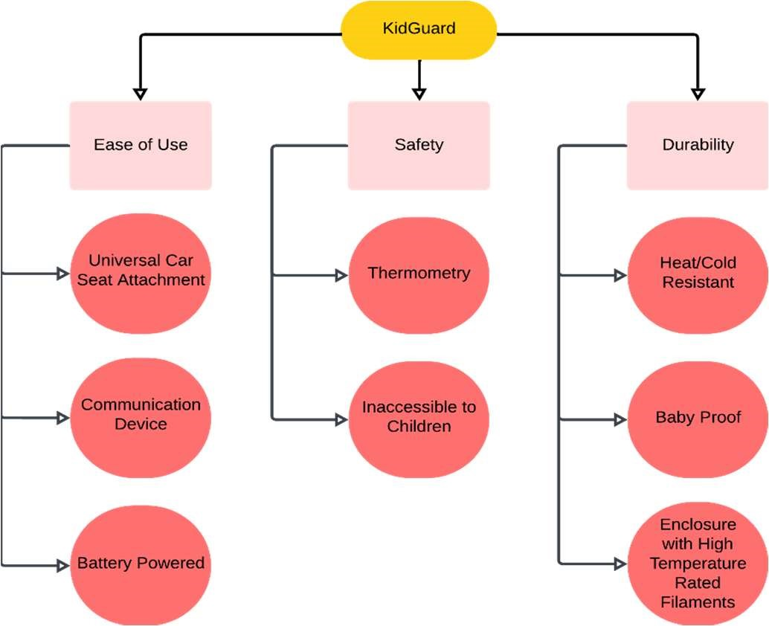

**Fig. 1-1. KidGuard’s Objective Tree**

These marketing requirements are the basis for the engineering requirements.

**1.1.2. Engineering Requirements**

KidGuard meets the engineering design requirements listed in Table 1-1 to achieve the marketing requirements.

# **Table 1-1: Engineering Design Requirements**

|  |  |  |
| --- | --- | --- |
| Marketing Requirements | Engineering Requirements | Justification |
| 1 | The load sensor detects a maximum of 110 lbs./50 kg | KidGuard detects if a child is seated in a standard car seat. |
| 2 | The user receives recurring reminders on the KG:S when a child is detected by KidGuard. | A guardian could forget their child in the car. |
| 2 | KidGuard includes reliable  communication to remind  guardians that a child is still in the vehicle and goes into alert mode when the connection is broken. | This ensures the user has a constant reminder of the child’s presence whether they are in range. |
| 3 | The thermal sensor detects temperature changes in a vehicle ranging from 58℉ to 302℉ (-50℃ to 150℃). | Children can perish when their body temperature reaches 107℉ (42℃) [1]. |
| 2, 3 | The user is notified of the temperature inside the vehicle. | At 85℉ and above (29℃), the interior is sweltering. These temperatures pose risks to the child. |
| 4 | KidGuard is battery operated. | KidGuard requires an easyto-access and replace battery source. |
| 5 | KidGuard is portable and compatible with all models of car seats. | Car seats come in different models and sizes [2]. |
| Marketing Requirements:   1. The KidGuard detects sufficiently large weights to identify if a baby is present. 2. The KidGuard notifies the user if the user is out of range and the baby is present. 3. The KidGuard senses the car’s interior temperature. 4. The KidGuard powering system lasts long enough when in use to function properly. 5. The KidGuard is universal to all car seats and is easily operable. | | |

These design requirements for KidGuard combined with various constraints, inform the design.

**1.2. Constraints**

KidGuard is faced with design specifications. KidGuard meets all the constraints listed in Table 1-2.

# **Table 1-2: Constraints**

|  |  |  |
| --- | --- | --- |
| Type | Name | Constraints |
| Economic | Cost | KidGuard has a budget constraint of $1000. |
| Economic | Time | KidGuard needs to be completed by December 2024. |
| Environmental | Heat Resistant | KidGuard’s conclusive design withstands exceptionally high temperatures. |
| Manufacturability | Enclosure | A casing protects the product from external factors including children, spills, and food. |
| Usability | Reliable | KidGuard communicates with KG:S without fail. |
| User Interface | Communication | KG:S displays data about the child via a display unit. |

KidGuard meets not only the constraints but also the engineering standards.

**1.3. Standards**

The KidGuard abides by the safety and engineering standards listed in Table 1-3.

# **Table 1-3: Engineering Standards**

|  |  |  |
| --- | --- | --- |
| Specific Standard | Standard Document | Specification/Application |
| No. 213 | FMVSS | KidGuard does not impede the original function of the child restraint system [2]. |
| IEEE  P1451.5.5 | IEEE Recommended Practice for Powering and Grounding Electronic Equipment | KidGuard adheres to standard safety wire protection for electronic devices [3]. |
| IEEE  802.11n-  2009 | IEEE Standard for IT– Local and metropolitan area networks– Specific requirements– Part 11: Wireless LAN MAC and PHY Specifications Amendment 5:  Enhancements for Higher Throughput | KidGuard uses Bluetooth to indicate a break in connection with a mobile device [4]. |

1. **DESIGN APPROACH**

KidGuard is a child protection device equipped with weight sensors, thermal sensors, and a communication system to notify users if a child is left unattended in a car seat. KidGuard detects the child’s presence with weight sensors and monitors the vehicle’s interior temperature with thermal sensors. Subsequently, the KG:S receives the collected data. Afterward, the KG:S displays the information to the user.

KidGuard’s critical constraints include a development cost of $1000, a completion deadline of December 2024, high-temperature endurance, and reliability. Furthermore, KidGuard abides by the FMVSS, Recommended Practice for Powering and Grounding Electronic Equipment, and IEEE Standard for Information Technology.

**2.1. Design Options**

Various design options were considered for KidGuard. The three design options below describe the choices on KidGuard’s design. The goal is to achieve accurate weight and thermal sensing while keeping the device away from children. Moreover, KidGuard must be reliable for the safety of the children.

KidGuard identified the communication subsystem as a major obstacle, particularly due to challenges with reliable user notifications. After evaluating various approaches, KidGuard selected Design Option 3, which demonstrated superior precision in addressing these issues compared to Design Options 1 and 2. The latter options presented significant barriers, including delayed or unclear user communication, making Option 3 the most effective choice.

**2.1.1. Design Option 1**

The first design option utilizes the LoRa communication device. This transmitting device can reach long distances to the user’s cell phone directly with the use of a second receiving device. The advantage that LoRa could have brought to KidGuard is long distance communication to the user. Using radio waves, LoRa was a viable option to relay our weight and temperature data to the user.

**2.1.2. Design Option 2**

The second design option utilizes Twilio API. This service provided the Arduino with a designated toll-free phone number that sends messages to the user’s cellphone directly as an SMS notification. The messages that would be sent are up to date temperature readings if a child is present.

* + 1. **Design Option 3**

The third design option leverages two HC-05 Bluetooth modules to create a smart monitoring system. In this setup, one HC-05 module acts as the Master, collecting weight and temperature data from sensors, while the other HC-05 operates as the Slave, receiving data from the Master and displaying it on an LCD screen. This LCD provides the user with real-time temperature information, and the device also includes red, yellow, and green LEDs that visually indicate temperature levels inside the vehicle, helping the user quickly assess the conditions.

Additionally, if the user moves too far from the vehicle while a child is still inside, the system triggers a buzzer, alerting the user to return.

An advantage of this design is its seamless Bluetooth communication with the KG:S. The LED color indicators provide a quick and intuitive display of the temperature severity, enhancing safety by delivering alerts briefly. The audible alarm acts as an additional safeguard, offering a multi-sensory alert system that emphasizes the urgency if a child is left unattended in a potentially unsafe environment. This user-friendly design aims to enhance situational awareness and ensure timely responses, promoting child safety in vehicles.

Due to reasons explained previously, Option 3 best aligns with KidGuard's mission to provide a practical, efficient safety solution for children in vehicles.

**2.2. System Overview**

KidGuard’s black box runs with a power supply that takes in different inputs to transmit a notification to the user. A simplified diagram of how KidGuard works is shown in Figure 2-1.

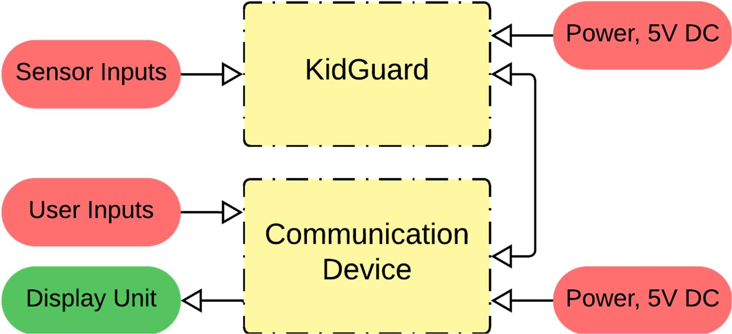

# **Fig. 2-1 KidGuard Functionality Overview (Level 0)**

KidGuard features numerous components to transform raw inputs into push notifications displayed to the user. Figure 2-2 provides an in-depth representation of the device.

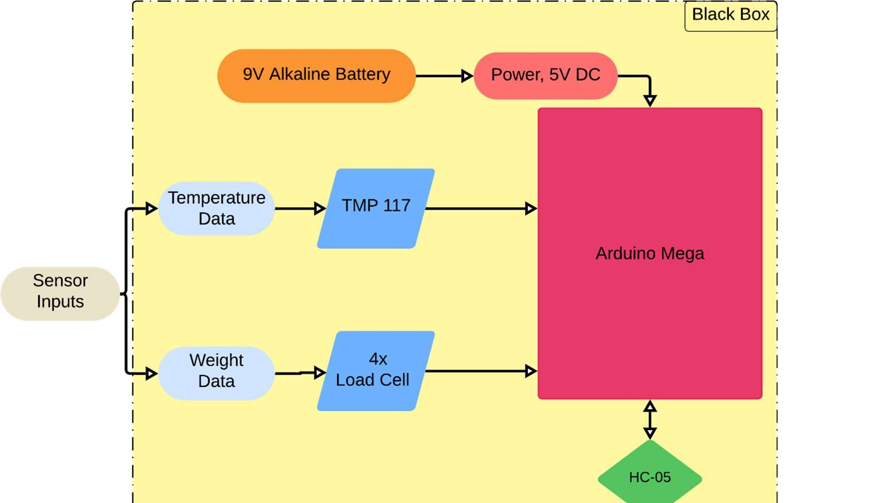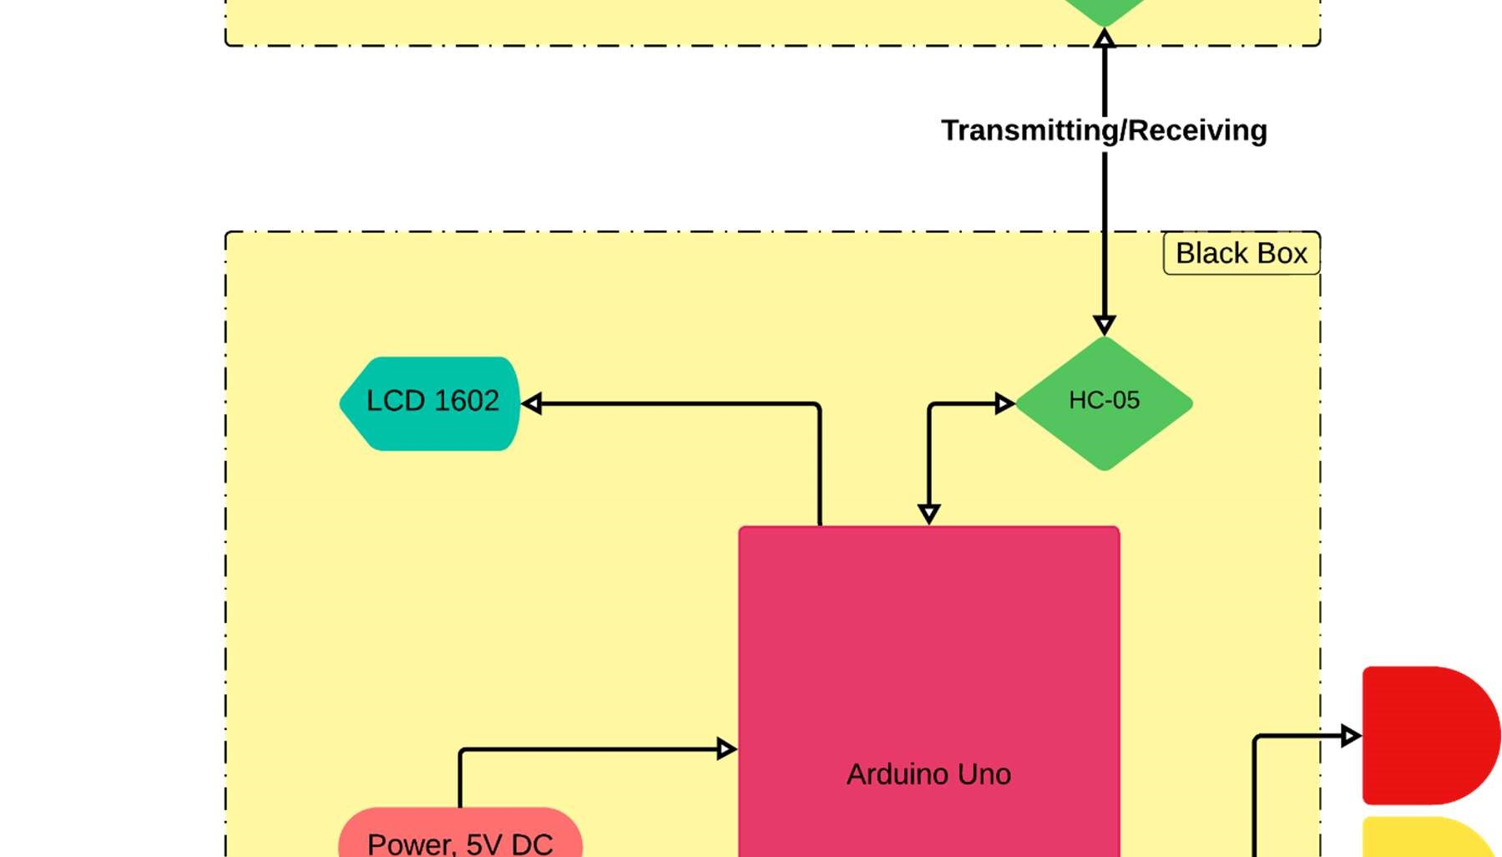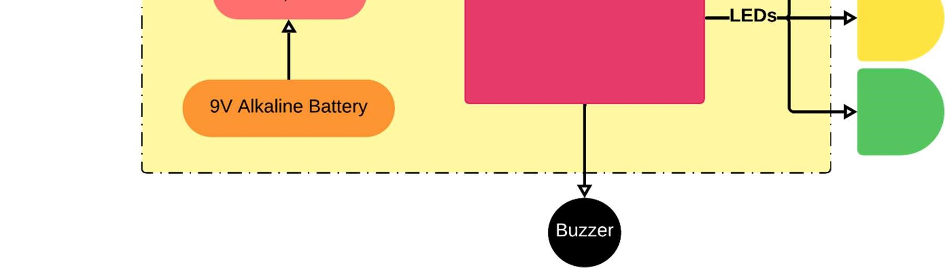

# **Fig. 2-2 KidGuard Functionality (Level 1)**

Inside KidGuard's black box, load cells detect a child's presence. The thermal sensor identifies dangerous high and low temperatures. The microcontroller, powered by a DC supply, processes incoming data. After this, the wireless transmitter sends a push notification to the user.

**2.2.1. Microcontroller**

KidGuard’s choice to use the Arduino Mega in Master mode, paired with the Arduino Uno in Slave mode, provides a flexible and robust communication framework. This Master-Slave setup leverages the Arduino Mega's wide selection of ports and straightforward usability, making it easy to manage multiple inputs. Using the terminal, KidGuard’s pin layouts match directly with code initialization, ensuring smooth communication between all subsystems. Table 2-1 illustrates the various microcontrollers that are considered.

# **Table 2-1: Microcontroller Comparison**

|  |  |  |  |  |  |
| --- | --- | --- | --- | --- | --- |
| Processor | Bluetooth | Dimensions (mm) | Operating Temperature | RAM | Price |
| Requirements | Yes | Max. 150 x 150 | 32 to 122°F (0 to 50°C) | 4 GB | ≤$100 |
| Raspberry Pi 4 Model B [5] | Yes | 95.3 x 70.1 | 32 to 185°F (0 to 85°C) [5] | 4 GB | $61.75 |
| Raspberry Pi 5 [6] | Yes | 86 x 56 | 32 to 185°F (0 to 85°C) [5] | 4 GB | $74.59 |
| Arduino Uno  [7] | No | 68.6 x 53.4 | -40 to 185°F (-40 to 85°C)  [8] | 32 KB | $27.60 |
| Arduino Mega  [9] | No | 50.8 x 101.6 x 25.4 | 40 to 185°F (-40 to 85°C)  [10] | 256 KB | $21.99 |

KidGuard chose the Arduino Mega for its cost-effectiveness, adequate size, and native compatibility with our chosen sensors and HC-05 Bluetooth device. Meanwhile, the Raspberry Pi options were too much of a “Jack-of-All-Trades” and exceeded KidGuard’s Application. The Arduino Mega supports USB and barrel jack ports; however, the final design uses a replaceable, portable 9V battery. Figures 2-3 depict the chosen microcontroller.

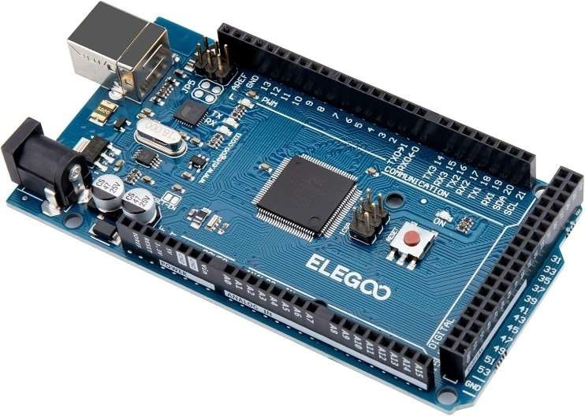

# **Fig. 2-3 Arduino Mega [9]**

KidGuard chose the Arduino Uno due to its smaller size and meeting the scope of the project’s requirements. Figure 2-4 depicts the microcontroller.

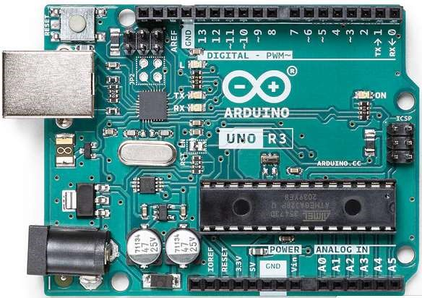

# **Fig. 2-4 Arduino Uno [7]**

KidGuard uses the Arduino Mega to collect weight and temperature data. The Master HC-05

Bluetooth module reads the data and sends the data via Bluetooth to the Arduino Uno in the KG:S. The Arduino Mega and Uno use a 9V alkaline battery power source with an easy on/off switch to conserve power.

**2.3. Subsystems**

KidGuard’s prototype design includes the following three subsystems:

1. The first subsystem is Bluetooth.
2. The second subsystem is the thermal sensor for high-temperature detection.
3. The third subsystem is weight detection for any pressure exerted in the seat to activate the device.

These three subsystems work together to transmit data to the user.

**2.3.1. Bluetooth**

For Bluetooth Communication, KidGuard requires a method to transmit data to KG:S. The team opted to use Bluetooth communication to send various health-related information. The Bluetooth module, HC-05, will sit inside of the enclosure attached to the back of the car seat and inside the enclosure for KG:S.

The communication system requires accurate, up-to-date notifications to ensure the safety of the child inside of the car. KG:S displays the temperature readings via the LCD to the user. Table 2-2 lists the component specifications of wireless transmitters.

# **Table 2-2: Bluetooth Comparison**

|  |  |  |  |  |
| --- | --- | --- | --- | --- |
| Model | Range (m) | Dimensions (mm) | Operating Temperature | Price |
| Requirements | ≤ 20 | Max. 70 x 50 | 32 to 122°F (0 to 50°C) | ≤ $100 |
| SX1262 LoRa HAT  [11] | 5000 | 65 x 30.5 | -40 to 185°F (-40 to 85°C) | $33.50 |
| Sixfab LTE-M [12] | 1000 | 57 x 65 | -13 to 158°F (-25 to 70°C) | $90 |
| Bluetooth Module HC-06 [13] | 10 | 36 x 15 | 23 to 149°F (-5 to 65°C)  [14] | $8.95 |
| Bluetooth Module HC-05 [15] | 10 | 37.3 x 15.5 | 23 to 149°F (-5 to 65°C) | $10.39 |

The Sixfab LTE-M and SX1262 LoRa HAT exceed the range standard that KidGuard requires, which is an enormous drawback. The HC-06 Bluetooth Module was about the same as the HC05, so either HC-06 or HC-06 meets the requirements for KidGuard. However, only the HC-05 has the capability for Master or Slave setting as HC-06 can only be a Slave.

Refer to Design II Update for further explanations regarding the SX1262 LoRa HAT. Figure 2-5 depicts an image of HiLetgo HC-05.

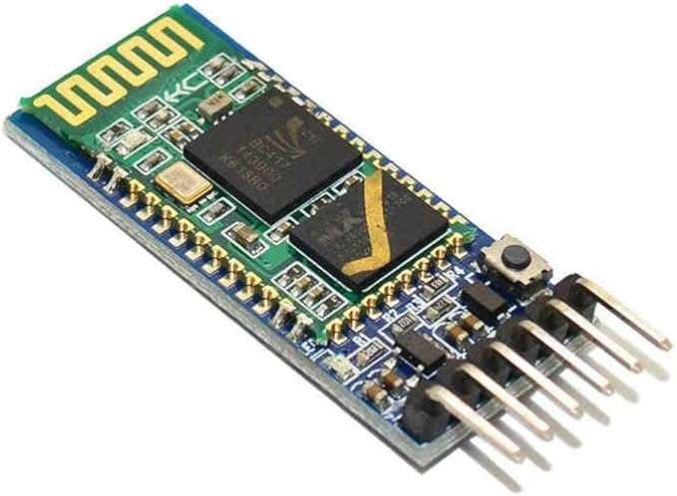

## **Fig. 2-5 HiLetgo HC-05 [15]**

The HC-05 Bluetooth module has VCC pins and ground for power, TX and RX pins to transmit and receive data, and the button is used to change the module to AT mode, Command mode, etc. KidGuard uses two Bluetooth modules to connect to each other to transmit and receive data.

**2.3.2. Temperature**

For the temperature subsystem, a thermal sensor detects the temperature inside of the vehicle. The data informs the user of harmful temperatures to the child. KidGuard’s utmost purpose is to limit the number of heat stroke-related deaths of children inside a hot vehicle. The temperature sensor KidGuard decided on is the SparkFun High Precision Temperature Sensor TMP117 (TMP117). Table 2-3 lists the component specifications of thermal sensors.

## **Table 2-3: Thermal Sensor Comparison**

|  |  |  |  |  |
| --- | --- | --- | --- | --- |
| Model | Thermometry | Dimensions (mm) | Operating Temperature | Price |
| Requirements | > 100°F  (>37.78°C) | Max. 100 x 100 x 100 | 32 to 122°F  (0 to 50°C) | ≤ $100 |
| SparkFun High  Precision  Temperature  Sensor - TMP117  [16] | -67 to 302°F  (-55 to 150°C) | 76.2 x 50.8 x 25.4 | -67 to 302°F  (-55 to 150°C) [17] | $14.95 |
| Raspberry Pi  Sense HAT [18] | 32 to 149°F (0 to 65°C) | 29.97 x 73.91 x 100.08 | 32 to 122°F  (0 to 50°C) [19] | $49.45 |
| Gikfun DS18B20  [20] | 14 to 185°F  (-10 to 85°C) | 147.3 x 15.2 x 99.1 | -67 to 257°F  (-55 to 125°C) | $11.58 |

In Figure 2-6, the SparkFun High Precision Temperature Sensor is displayed below. KidGuard utilizes the TMP117 for its high-temperature measurement capability (thermometry) and operating temperature range. KidGuard compared the TMP117 to the Raspberry Pi Sense HAT (Sense HAT) as well as the Gikfun DS18B20 (Gikfun).

The Sense HAT’s operating temperature range is inadequate, risking malfunction in elevated temperatures equal to and above 122°F (50°C), which is typically achieved in the vehicle’s interior during summer. The Gikfun surpasses the Sense HAT’s operating temperature range but cannot match the breadth of the TMP117.

Although the Gikfun’s operating temperature is near TMP117, its primary application is for food and beverage as opposed to an ambient temperature thermometer. For these reasons, KidGuard decided on the TMP117, as shown in Figure 2-6.

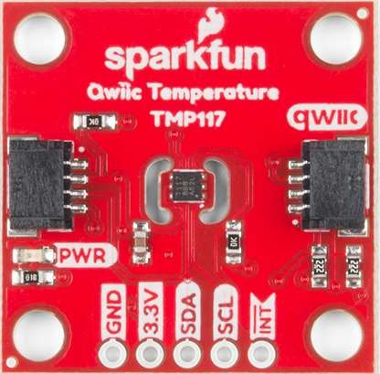

## **Fig. 2-6 SparkFun High Precision Temperature Sensor - TMP117 [16]**

The temperature sensor on KidGuard reads data for the Arduino Mega to keep up-to-date temperatures every second when it is not in standby mode. Until then, pressure must be applied to the seat, which activates the weight detection subsystem.

**2.3.3. Weight Detection**

KidGuard uses four generic Half Bridge Strain Gauge load cells assembled in a Wheatstone bridge pattern. The weight detection subsystem ensures that a child is in the car seat before picking up temperature readings. This prevents the user from getting unnecessary temperature readings if the child is not in the vehicle.

The weight detection subsystem activates the device if more than or equal to 2.2 lbs. (1kg) pressure is applied. If the required amount of pressure is applied, the seat activates to start all subsystems and leave standby mode. Table 2-4 lists the component specifications of load cells.

# **Table 2-4: Load Cell Comparison**

|  |  |  |  |  |
| --- | --- | --- | --- | --- |
| Model | Weight Range | Dimensions (mm) | Operating Temperature | Price |
| Requirements | 0 to 100 lbs. (0 to 45 kg) | Max. 45 x 45 | 32 to 122°F (0 to 50°C) | ≤$50 |
| Dorhea [21] | 0 to 110 lbs. (0 to 50 kg) | 34 x 34 | 32 to 122°F (0 to 50°C) | $9.99 |
| Uxcell [22] | 0 to 220 lbs. (0 to 100 kg) | 42 x 38 | -4 to 149°F (-20 to 65°C) | $10.09 |
| FX292X-100A  [23] | 10 to 110 lbs.  (4.54 to 49.9 kg) | 10.5 (Diameter) | 32 to 185°F (0 to 85°C) | $34.68 |
| Half Bridge  Strain Guage [24] | 0 to 441 lbs.  (0 to 200 kg) | 38.1 x 17.78 | MAX  248 to 266°F  (120 to 130°C) | $8.99 |

KidGuard chose the Half Bridge Strain Gauge load sensor for its high-weight detection range and its high heat resistance. The Half Bridge Strain Gauge’s curved rectangular flat design allows it to fit comfortably underneath the padding of a car seat. In Figure 2-7, the Half Bridge Strain Gauge is displayed.

The FX29X offers an acceptable temperature range. However, the minimum activation weight does not allow premature children or newborns to be detected. The physical structure of the FX29X is taller than the other options listed, which leads to a problem of comfortability as the load cell is placed under the padding of the car seat.

The Dorhea load cells fit the scope of the project. However, only meets the bare minimum requirements.

Refer to Design II Update for further explanations regarding the Uxcell load cells.

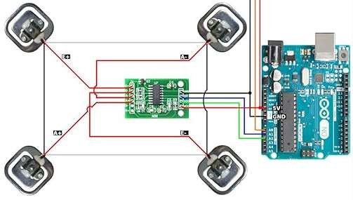

## **Fig. 2-7 Half Strain Bridge Gauge Load Cells [25]**

**2.4. Level 2 Prototype Design**

The completed KidGuard prototype consists of a fully functioning KG:S that can accurately display data from KidGuard to the user. The KidGuard sends data to the KG:S, which is then shown on the LCD and LEDs. When the temperature is in the danger zone or the connection is broken, a buzzer will sound to alert the KidGuard’s microcontroller in a 3D-printed box stored in the undercarriage of the car seat. KidGuard has sufficient power to stay active for 10 to 15 hours.

KidGuard runs on Arduino to operate each subsystem. Arduino includes all necessary libraries for the thermal sensors, load cells, and HC-05. Additionally, the information that is processed by the Arduino Mega is sent to the KG:S. The handheld KG:S communicates seamlessly with the KidGuard.

**2.4.1. Level 2 Diagram**

KidGuard’s final prototype design is shown in Figure 2-8. The first enclosure includes the Arduino Mega, HC-05 Bluetooth module, HX711 with load cells, TMP117, and 9V Alkaline battery. This enclosure is mounted to the car seat. The second enclosure, KG:S, includes the Arduino Uno, HC-05 Bluetooth module, 3 LEDs, LCD 1602 display, buzzer, and 9V Alkaline battery.

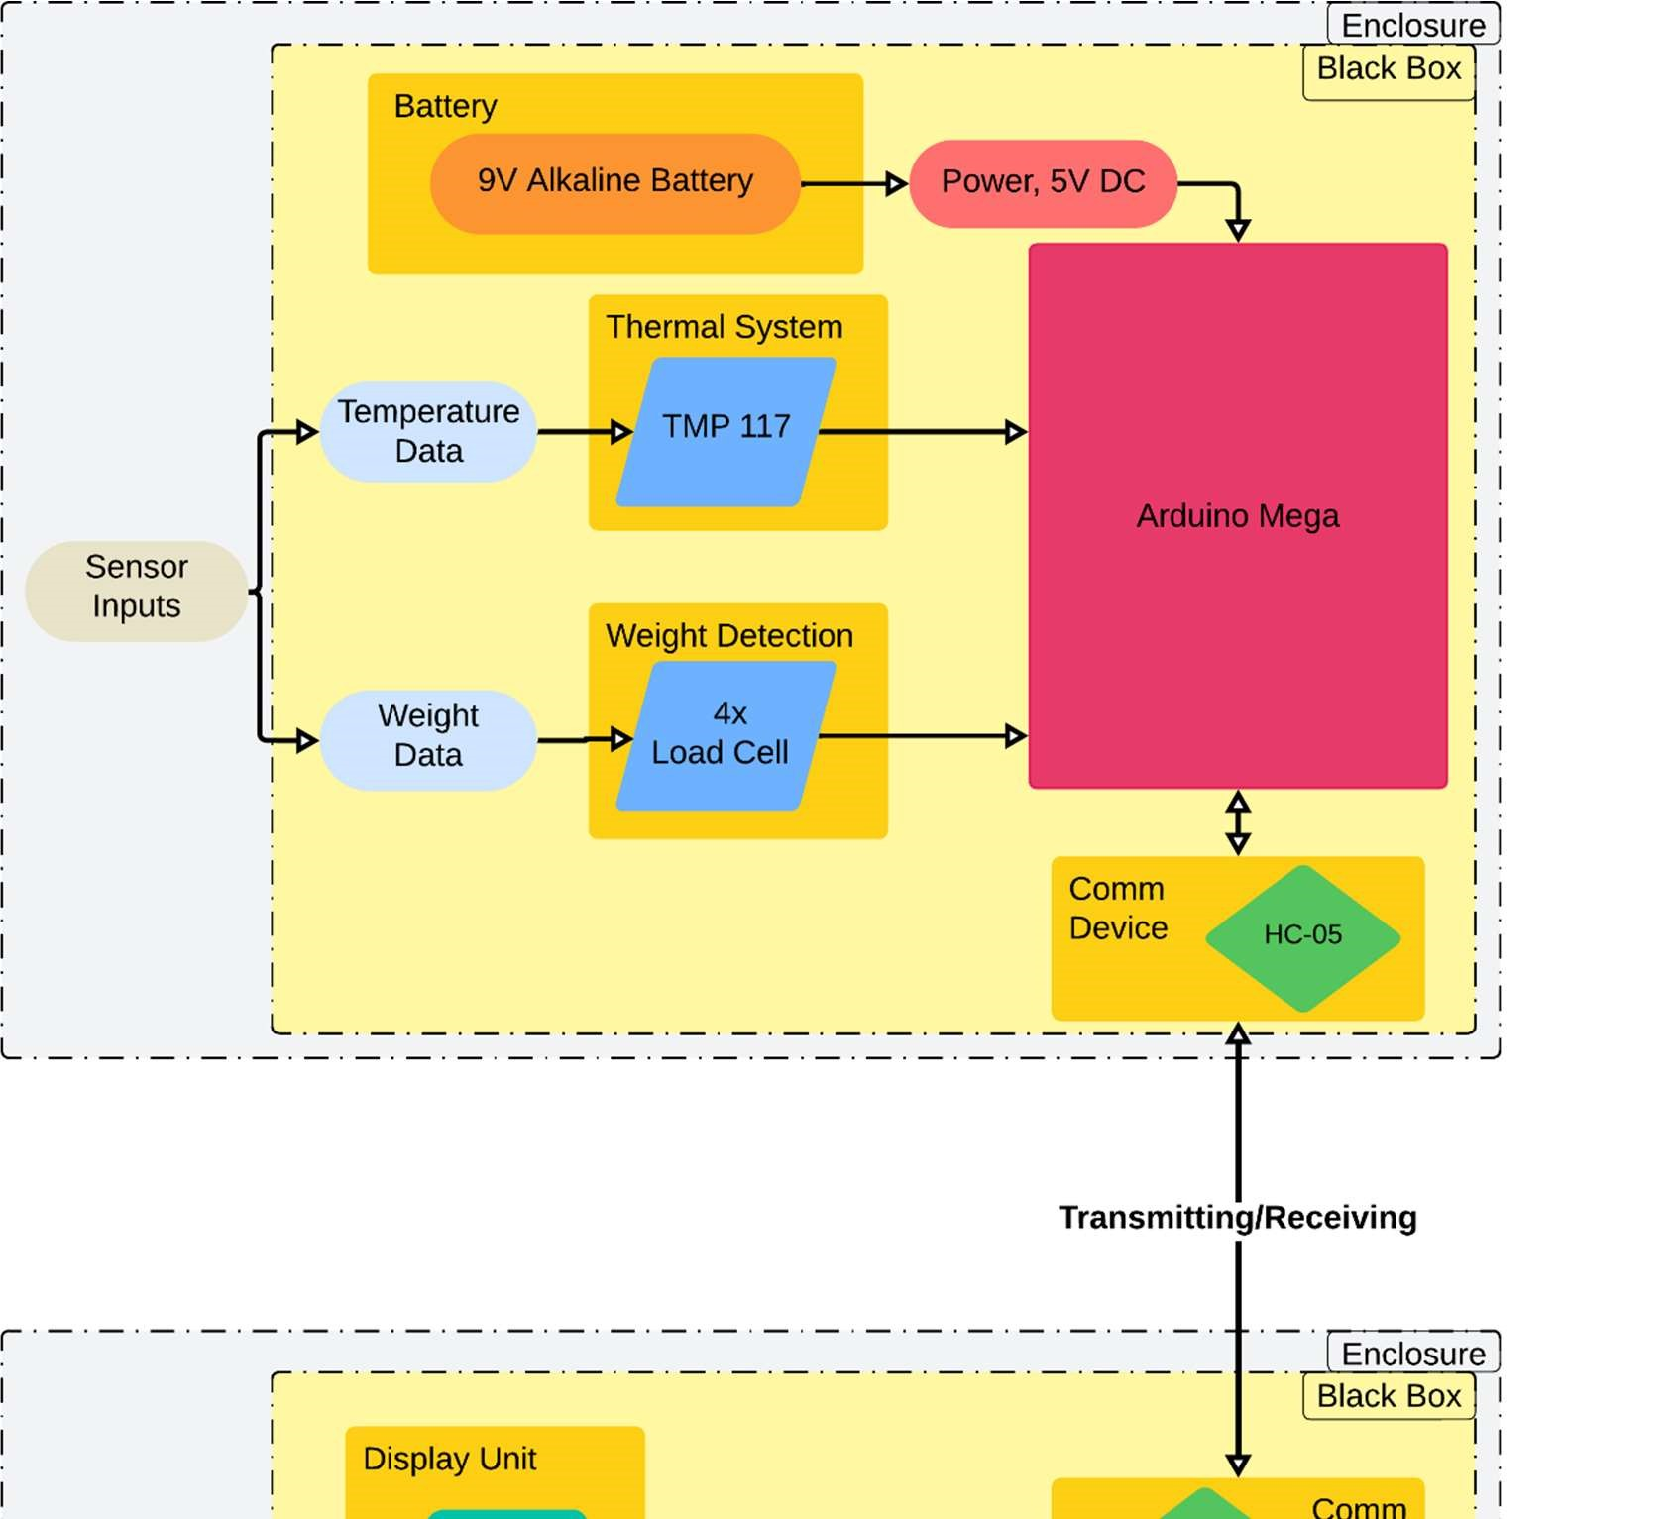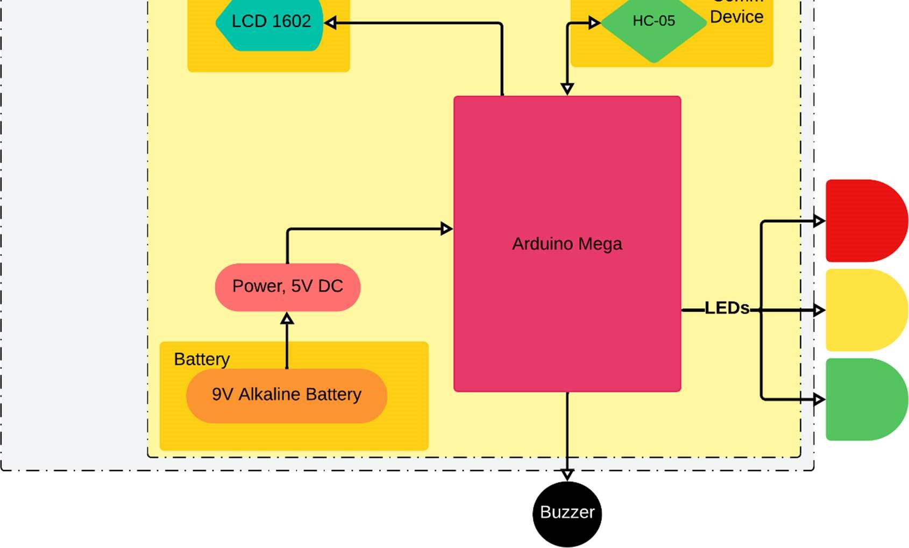

## **Fig. 2-8 Level 2 Diagram for KidGuard (Level 2)**

The first enclosure collects data from the load cells and TMP117 temperature sensor to send to the HC-05 Master Bluetooth module. The Arduino Mega interacts with all three and is powered by a 9V Alkaline battery. The data is sent to the KG:S which has the HC-05 Slave Bluetooth module that receives and displays the data on the LCD display. The LEDs display the corresponding temperature in the vehicle. The buzzer alarms the user if the KG:S is out of range from the vehicle or the red LED turns on. The KG:S includes an Arduino Uno powered by a 9V Alkaline battery.

The sections above accurately describe KidGaurd’s product approach. Each section meticulously describes the functional operation of the subsystems and their components. The next portion discusses testing procedures, results, and troubleshooting.

**3. EVALUATION**

KidGuard is meant to always remain in the vehicle, which means that the device needs to run without the use of a computer or laptop for power. Along with this, KidGuard needs to relay accurate up to date data to the KG:S. This data includes weight detection, thermal sensing, and reliable Bluetooth connectivity.

**3.1. Test Certification – Sound Buzzer**

The sound buzzer attached to KG:S plays a sound whenever Bluetooth connection breaks or temperature rises above 80°F (26.67°C).

**3.2. Test Certification – LEDs**

Figure 3-1 displays the LEDs as operational depending on the color.

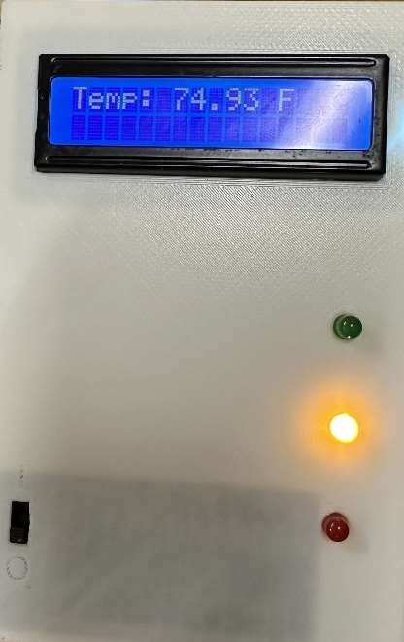 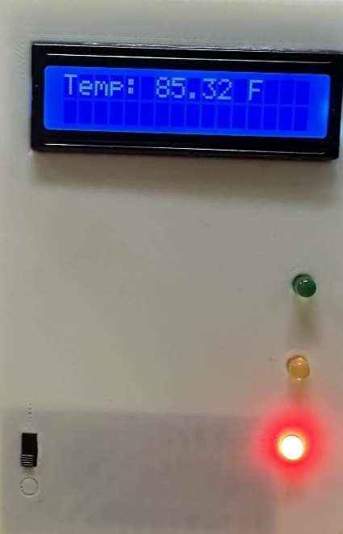

## **Fig. 3-1 LEDs**

**3.3. Test Certification – Power**

KidGuard and KG:S are powered on in Figures 3-2, and 3-3.

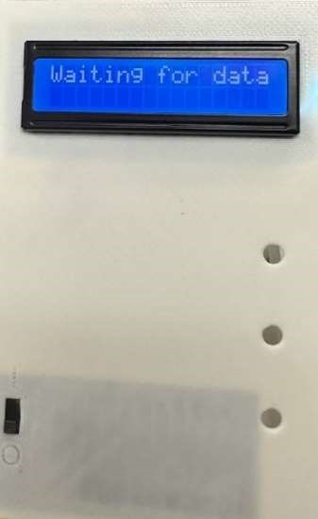



**Fig. 3-2 KidGuard Power System** **Fig. 3-3 KG:S Powered On**

The battery is turned on using an on/off switch to test if the Arduino can run the the code independently of computer. The temperature sensor flashes red, while the Arduino shows a green light to indicate it is powered on. In this mode, the HC-05 communicates with the KG:S.

The KG:S works as intended as it waits to receive data from KidGuard.

**3.4. Test Certification – Temperature Range**

In Figure 3-4, the KG:S displays the ambient temperature around the car seat. The communication of this data to the KG:S is the backbone of the product.

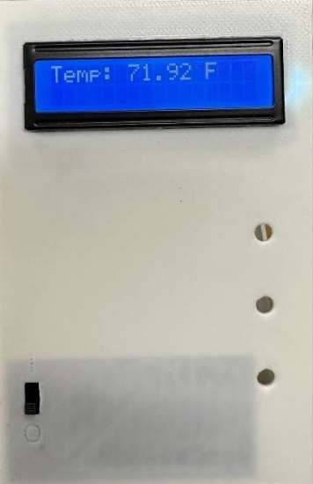 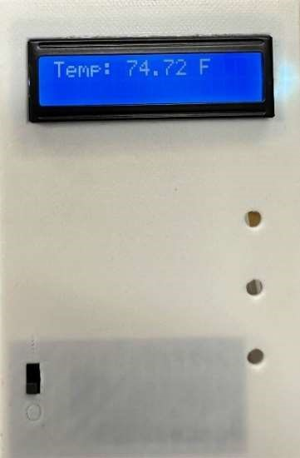

**Fig. 3-4 KidGuard Temperature Test**

**3.5. Test Certification – Weight Sensor**

The Half Bridge Strain Gauges correctly detects weight over 2.2 lbs. (1 kg).

**4. SUMMARY AND FUTURE WORK**

KidGuard had issues with the communication subsystem, but the rest was worked out with a good team effort. The weight detection and thermal sensor were flawless in reading data, and the 3D modeling of the KidGuard and KG:S did not take long to make. KidGuard wanted long range communication with the device, but many obstacles obstructed this task such as uploading to the internet from a vehicle, communicating with the LoRa device long range, and getting text messages to send to a user. Bluetooth communication works great until the user reaches a certain range, but the buzzer is the alternative to alert the user to go back when the signal is broken. In the future, KidGuard would like to rework the distance of communication to allow for longer communication between the users. Additionally, KidGuard would like to create a crib monitor to allow supervision from home

**5. BUSINESS PLAN**

The upcoming sections provide a detailed overview of KidGuard’s business plan, highlighting key strategies for market entry, target audience, and projected growth.

**5.1. Objectives**

* + - * Increase product manufacturing by 20% over the next five years.
      * Expand company exposure to areas beyond the southern United States.
      * Work on making the product more cost effective and affordable for low-income families.
      * Lower the amount of child deaths from heatstroke.

**5.2. Keys to Success**

* + - * Increasing our brand exposure amongst young parents.
      * Ensuring that each KidGuard produced has been tested to ensure reliability and functionality.
      * Maintaining a detailed account of our production and sales.

**5.3. Plan Overview**

This section provides a comprehensive overview of the KidGuard initiative, detailing our mission, objectives, keys to success, competitive advantages, target market, and basic strategies. It highlights our commitment to child safety, market expansion, cost-effectiveness, and innovation to make a meaningful impact on families and communities.

* + 1. **Mission**

Our mission at KidGuard is to strive for excellence in every endeavor we go after. Our mission is simple, safety, and excellence above all. At KidGuard, building and creating a safer world for children is our utmost priority. KidGuard is made to ensure that children’s deaths will be lowered. KidGuard’s mission is to be a lifeline for stressed parents and keep the children safe.

* + 1. **Objectives**
* Increase product manufacturing by 20% over the next five years.
* Expand company exposure to areas beyond the southern U.S.
* Work on making the product more cost effective and affordable for low-income families.
* Lower the amount of children’s heatstroke deaths.
  + 1. **Keys to Success**

There are several keys to success that are important to KidGuard. Increasing our brand exposure amongst young parents. Ensuring that each KidGuard Climate Monitor produced has been tested to ensure reliability and functionality. Maintaining a detailed account of our production and sales.

* + 1. **Competitive Advantage**

KidGuard’s main competitor is the Doona SensAlert, a Bluetooth device designed to alert users if a child is left in the vehicle. A significant drawback of the Doona SensAlert is its compatibility, as it only works with the Doona Car Seat and detects only if a child is in that specific seat. In contrast, KidGuard can be attached to any car seat and monitors the temperature inside the vehicle, providing real-time information on the child's environment. KidGuard communicates with the user via Bluetooth and offers up-to-date temperature readings.

* + 1. **Target Market**

The market for KidGuard is focused on commercial and national distribution, with plans to expand internationally in the future. Our target consumers are parents who have young children in car seats or booster seats and prioritize their child’s safety and wellbeing. We aim to make child safety accessible by offering an affordable option, providing families with a reliable solution they may not have had access to before.

* + 1. **Basic Strategies**

One basic strategy for startup funding is to launch GoFundMe. We will put KidGuard on Facebook marketplace since adults use this social media platform. Our marketing team will make short ads to catch the viewers’ attention to convince them to buy our product. For distribution, we will initially focus on the United States, selling KidGuard through our website, where we will handcraft and ship each device ourselves. Based on sales performance, we will create different versions of our product that function in cold environments.

* 1. **Company Summary**

This section summarizes the core elements that make KidGuard unique, from its founding vision to its operational strategy. KidGuard LLC is a locally owned company with private investors, committed to developing solutions for child safety. It covers our company's description, location, facilities, strategic goals, and anticipated startup costs, outlining how we plan to launch and sustain our product in the market.

* + 1. **Company Description**

Micah Pickering is the founder of KidGuard LLC.

* + 1. **Company Location and Facilities**

KidGuard is housed in a factory and office space. This small factory allows us to produce our product. We are using office space for management as well as a storage facility as the product is small.

* + 1. **Company Strategy**

KidGuard will use crowdfunding and Kickstarter to fund the company project for the first year. Create a website for online ordering after we have received the funding for the product for consumers to buy. Use social media to create a KidGuard Facebook group for users to share about their experiences using the product. Allowing the KidGuard name to get out there and talked about. After two years, we will have a warehouse for our product and a distributor for stores. Once we have a stable market for our product, we will look for investors to help market the KidGuard.

* + 1. **Startup Costs**

Figure 5-1 includes the approximate startup costs for funding KidGuard LLC.

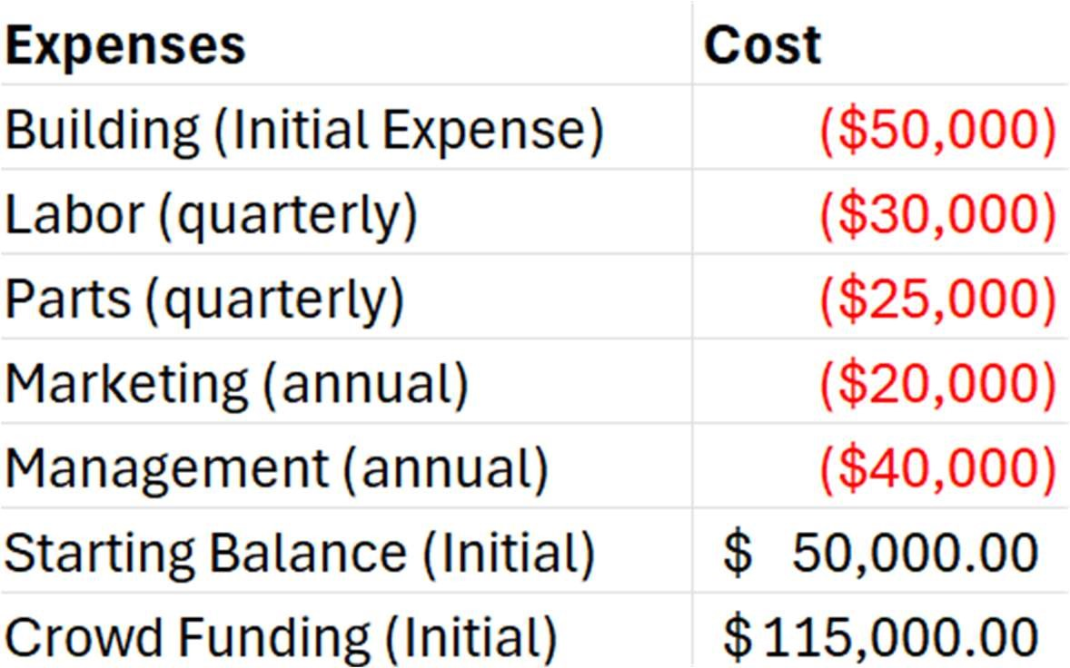

## **Fig. 5-1 Startup Costs**

Building – The $50,000 cost of the building is for the manufacturing and storage of products. This will go towards renting a small factory and office space.

Labor – The $30,000 quarterly cost covers our small labor force.

Parts – The $25,000 quarterly cost covers the cost of parts needed to build the KidGuard.

Marketing – Using $20,000 to market our product effectively will allow us to get our brand more exposure and allow for more sales.

Management – The $40,000 cost for management is to pay for the factory/warehouse manager. Their job is to oversee production and storage.

Starting Balance – The $50,000 starting balance is a bank loan acquired for the purpose of getting our factory and warehouse.

Crowd Funding – The $115,000 from crowdfunding resources like Kickstarter and GoFundMe and door to door sales pitching. This allowed us to pay for our employees and purchase parts and materials.

**5.5. Product Summary**

This section provides an in-depth overview of the KidGuard product, outlining its design, purpose, and functionality. It includes a detailed description of the product, highlights the customer needs, and benefits it addresses, explores potential future product expansions, and compares KidGuard with similar devices on the market.

**5.5.1. Product Description**

KidGuard is a lifesaving device for children. It features a mountable housing unit, four weight sensors, thermal and a communication system. The unit is placed on the backside of the car seat with the sensors tucked underneath the cloth lining of the seat. The communication system interacts with KG:S and relays temperature and weight data back to them.

**5.5.2. Customer Needs and Benefits**

KidGuard notifies the consumer if they have forgotten their child in the vehicle. It will send realtime information to the consumer's phone to let them know what the temperature of the vehicle is. It will help people who are in tricky situations and help them remember their child in the vehicle.

**5.5.3. Future Products**

KidGuard Crib Monitor monitors a child’s movement in their crib, detecting and tracking their sleep patterns. The Crib Monitor uses motion sensing technology to give parents and guardians a detailed look at their kid’s sleep. Allowing them to help set up better bedtime routines.

**5.5.4. Competitive Comparison**

Doona SensAlert is a Bluetooth device that communicates to the user if a child is left in the car. KidGuard is also a Bluetooth device that communicates the temperature inside of a vehicle as well as the weight detection of a child to the user if a child is left in the car.

**5.6. Market Summary**

This section provides an overview of KidGuard's target market, marketing strategies, projected sales, and approach to manufacturing and distribution.

**5.6.1. Market Analysis**

The target audience for KidGuard is the average parent or guardian in areas where the demographic is typically hotter than others such as Arizona or the humidity in the South.

**5.6.2. Marketing Strategy**

Our market strategy will be as follows: Typical advertisements that you would see as ads in-between shows, customer reviews, local distribution with word of mouth between parents, and when the product receives more attention show off or advertise the products on various social media platforms.

**5.6.3. Sales Projection**

In the first year, we plan on making 100,000 sales, which would help fund the future growth of the company and allow us to reach out to bigger distributors, such as Amazon. In the second year, we plan to reach out to 300,000 sales as our product grows in popularity from social media platforms such as TikTok influencers. By the third year, our goal is 500,000 sales to reach as many children as possible. Currently, our milestones are getting the weight detection working perfectly, and the thermal sensor correctly measuring the temperature.

**5.6.4. Manufacturing and Distribution Strategy**

Since the hardware is simple, we can have it assembled by hand instead of investing in high-cost specific assembly lines. We will start out with our own website where you can order from before moving to bigger distributors like Amazon.

Risk Management: We will create a label on the box that says: “Avoid water spills on KidGuard as it is an electrical device.” We will also provide a QR code on the box that will lead to our support team if they have any questions.

There are potential issues with connecting to Bluetooth since it has limited range and is affected by other Bluetooth devices being used in the same area.

**5.7. Organization Overview**

This section outlines the organizational structure and personnel plan for KidGuard, detailing the roles and responsibilities within the company.

**5.7.1. Company Structure**

Figure 5-2 organizes the hierarchy of the company with Micah Pickering at the top of the company with the rest of the group in charge of other subbranches.

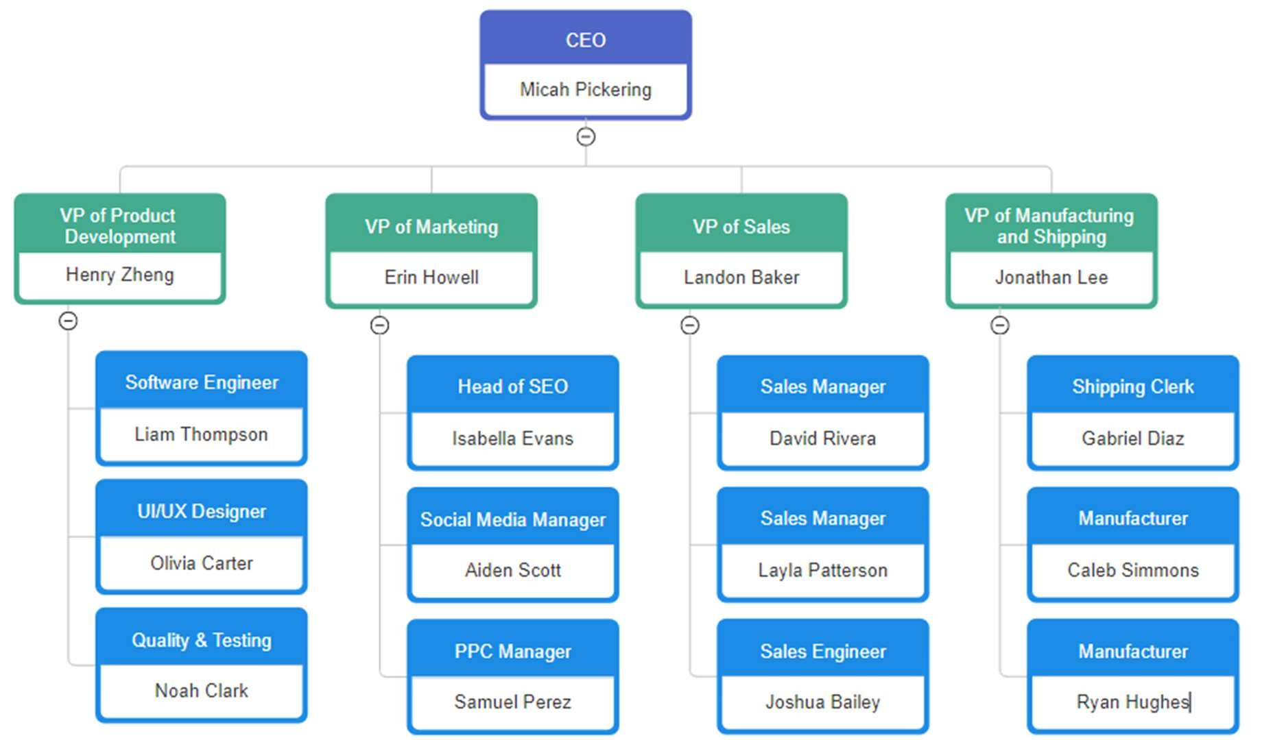

## **Fig. 5-2 Hierarchy of KidGuard LLC**

**5.7.2. Personnel Plan**

KidGuard’s workers will have 40-hour work weeks, $25 an hour, and no overtime. The cafeteria is available to all employees but costs $8 per meal. The first team will be over the manufacturing of the products with getting all the parts in order and assembling KidGuard. Another with loading the Arduino code to all the devices to make sure that KidGuard runs smoothly. A third team oversees evaluating the product at varying temperatures. An additional team manages the organization and sales of our product and distribution. Furthermore, there will be a marketing team to ensure our product will be known and seen by others. Lastly, employees are trained to follow standard safety and emergency procedures to prevent accidents and to respond appropriately if they occur.

**5.8. Financial Plan**

Our financial plan for year one is to reach target audiences on social media platforms and gain trust from our consumers that the product is viable. For year two, we plan to upgrade our sales department to sell more of our products. For year three, we plan to grow our company worldwide with different distribution companies.

**5.8.1. Profit and Loss**

* Parts and materials to create more product.
* Packaging for the product to give professionalism and appeal for the product.
* Social media advertisement coverage to spread interest in the product. • Building to store the product and for workers to do their jobs • Labor for faster producing times.
* Management for a stable business

**5.8.2. Projected Cash Flow**

Figure 5-3 entails the projected cash flow in thousands of USD from different subbranches to keep the company running efficiently.



## **Fig. 5-3 Projected Cash Flow**

**5.8.3. Projected Balance Sheet**

Figure 5-4 displays the projected balance updates after each quarter of the year.

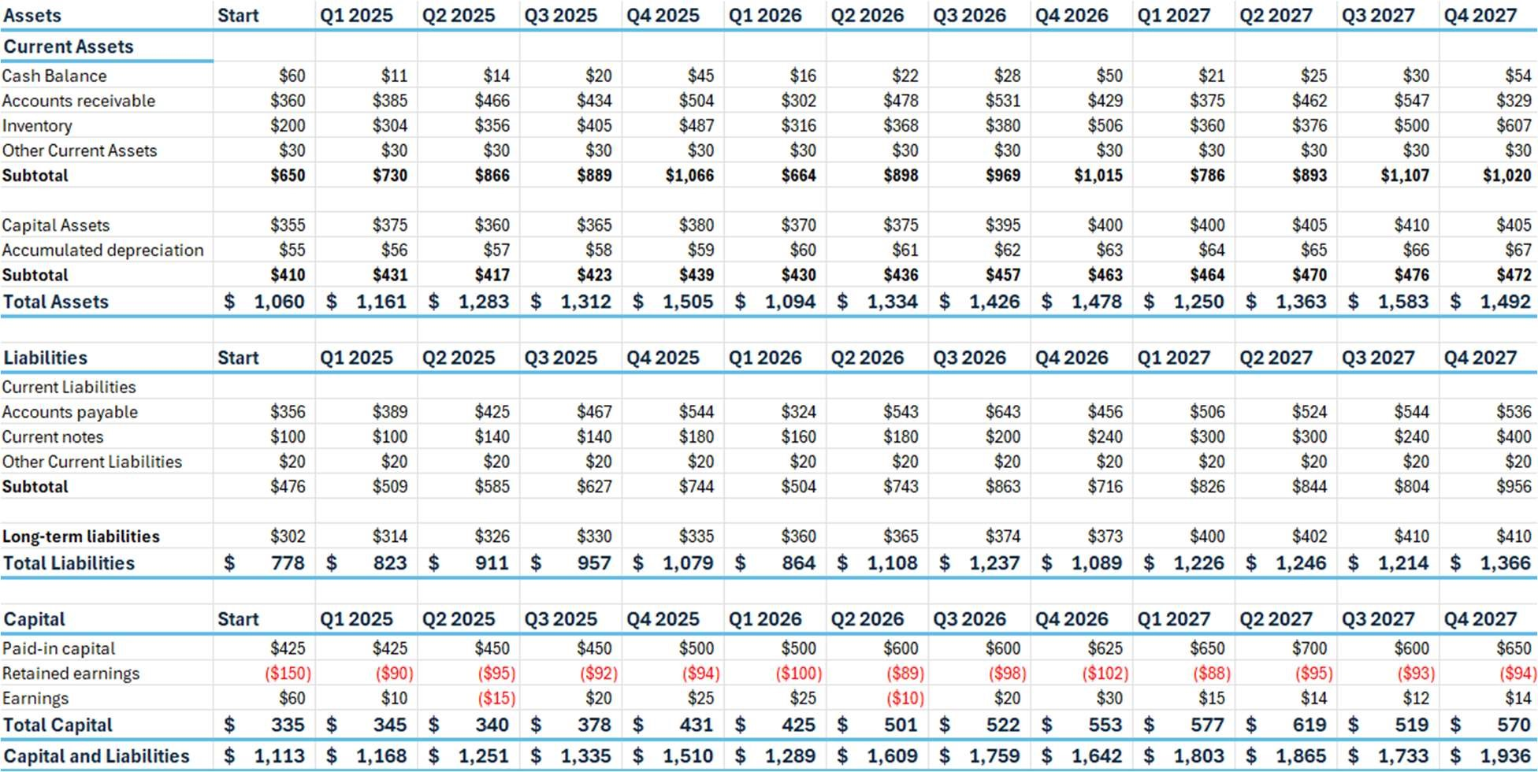

## **Fig. 5-4 Projected Balance Sheet**

**6. DESIGN II UPDATES**

Initially, the project decided to use the Raspberry Pi 4B as our microcontroller due to its high computational power for our project, but due to issues with the Raspberry Pi 4B OS it severely limited what our team could accomplish with the software. There were also complications on how we could turn on the Raspberry Pi 4B without having to open the source code and run our hardware because we wanted our device to be used as soon as it is powered on without any external interventions.

Due to these reasons, our team decided to use a mixture of the Arduino Mega and Uno to fit our needs.

The communication system faced challenges resulting in a drastic overhaul of how our team approached the problem. Consequently, the idea of using LoRa communication was set aside due to issues with outdated or unavailable code and libraries.

As such we moved away from using SX1262 LoRa Hat and attempted to use Twilio API to communicate instead. However, it was difficult to acquire the phone number and documentation using Twilio API in our source code.

Another issue with the communication system was how our consumers were able to receive and interpret sensor data. Our original plan was to use a Web app and have the LoRa upload the data to the internet, and we would have the data update in real time as it transmits. There was also a similar idea with Twilio where it would send SMS notifications to the phone directly. However, because of these challenges our team decided to build a portable communication device (KG:S). The appliance manages data and signals as an extra device that can be carried around.

Due to these reasons, our team decided to use Bluetooth modules as our form of communication in the end.

The load cells initially used had difficulties being read accurately due to our lack of knowledge requiring the formation of the Wheatstone bridge to be used. However, our equipment disappeared and as a result we ordered a generic Half Bridge Strain Gauge, which worked as intended and as expected for the weight subsystem.

Due to significant changes in the project and system management, the team transitioned from using Raspberry Pi 4B with Python and Arduino on a Linux system to the Arduino IDE 2.3.3 on Windows to implement the necessary updates.

**7. ACKNOWLEDGEMENTS**

The design team wishes to acknowledge Mississippi State University for funding our project. The team wishes to express our appreciation to Professor Yu Luo and Timothy Sellers for their expertise, guidance, and assistance in the creation of our final design.

**8. REFERENCES**

1. “Child Heatstroke Prevention: Prevent Hot Car Deaths.” National Highway Traffic Safety Administration (NHTSA). https://www.nhtsa.gov/campaign/heatstroke (accessed Mar. 5, 2024).

1. “Federal Motor Vehicle Safety Standards; Child Restraint Systems, Incorporation by

Reference,” Federal Motor Vehicle Safety Standards No. 213, Federal Register. (2020, Nov. 02). https://www.federalregister.gov/documents/2020/11/02/2020-21477/federalmotor vehicle-safety-standards-child-restraint-systems-incorporation-by-reference (accessed Mar. 5, 2024).

1. “Institute of Electrical and Electronic Engineers Standards Association (IEEE SA) - standard for a smart transducer interface for sensors and actuator -- wireless communication protocols and transducer electronic data sheet (TEDS) formats - LoRa Protocol,”IEEE standard p1451.5.5, IEEE Standards Association. (2021, May 21).

https://standards.ieee.org/ieee/1451.5.5/10611/ (accessed Mar. 5, 2024).

1. “Institute of Electrical and Electronic Engineers Standards Association (IEEE SA) - IEEE Standard for Information technology-- local and metropolitan area networks-- specific requirements-- part 11: Wireless LAN Medium Access Control (mac) and Physical Layer (PHY) specifications amendment 5: Enhancements for higher throughput,” IEEE standard 802.11n 2009, IEEE Standards Association, (2009, Oct. 29).

https://standards.ieee.org/ieee/802.11n/3952/ (accessed Mar. 5, 2024).

1. "Heating and Cooling Your Raspberry Pi" Raspberry Pi [Online]. Available:

https://www.raspberrypi.com/news/heating-and-cooling-raspberry-pi-

5/#:~:text=To%20prevent%20overheating%2C%20all%20Raspberry,temp%20of%2085° C. (accessed Apr. 4, 2024).

1. "LDLC.com - High-Tech Expérience - Product" LDLC [Online]. Available:

https://www.ldlc.com/en/product/PB00574323.html. (accessed Apr. 4, 2024).

1. “Arduino Uno REV3,” Arduino Online Shop, https://storeusa.arduino.cc/products/arduino-uno-rev3?selectedStore=us (accessed Apr. 4, 2024).

1. Arduino Support, "What is the operating temperature range for Arduino boards?," https://support.arduino.cc/hc/en-us/articles/360016076980-What-is-the-operatingtemperature-range-for-Arduino-boards. (accessed Apr. 4, 2024).

1. "ELEGOO Mega R3 Project The Most Complete Ultimate Starter Kit Compatible with Arduino IDE," Amazon. Accessed: Oct. 31, 2024. [Online]. Available: https://www.amazon.com/ELEGOO-Compatible-Arduino-ProjectsCompliant/dp/B01H4ZLZLQ

1. "Arduino Mega 2560 Rev3," Arduino Documentation. Accessed: Oct. 31, 2024.

[Online]. Available: https://docs.arduino.cc/resources/datasheets/A000067-datasheet.pdf

1. "SX1262 915M LoRa HAT" WaveShare [Online]. Available:

https://www.waveshare.com/wiki/SX1262_915M_LoRa_HAT. (accessed Apr. 4, 2024).

1. "Raspberry Pi Cellular IoT Kit – LTE-M" Sixfab [Online]. Available:

https://sixfab.com/product/raspberry-pi-cellular-iot-kit-lte-m/. (accessed Apr. 4, 2024).

1. Tinkersphere, "Bluetooth Module HC-06 (Arduino Compatible)" [Online]. Available:

https://tinkersphere.com/sensors/709-Bluetooth-module-hc-06-arduino-compatible.html. (accessed Apr. 4, 2024).

1. Rajguru Electronics, "HC-06 TTL Bluetooth Module" [Online]. Available:

https://www.rajguruelectronics.com/ProductView?product=HC-

06%20TTL%20MODULE&tokDatRef=NzA4&tokenId=NDA=. (accessed Apr. 4,

2024).

1. "HiLetgo Wireless Bluetooth Transceiver HC-05 RF Wireless Bluetooth Module for Arduino," Amazon. Accessed: Oct. 31, 2024. [Online]. Available: https://www.amazon.com/HiLetgo-Wireless-Bluetooth-TransceiverArduino/dp/B071YJG8DR

1. "SparkFun High Precision Temperature Sensor - TMP117 (Qwiic) - SEN-15805" Amazon.com [Online]. Available: https://www.amazon.com/SparkFun-High-PrecisionTemperature-Sensor/dp/B081QK731D. (accessed Apr. 4, 2024).

1. Texas Instruments, "TMP117 High-Accuracy Digital Temperature Sensor," [Online]. Available: https://www.ti.com/lit/ds/symlink/tmp117.pdf. (Accessed: 04-Nov-2024).

1. "Raspberry Pi Sense HAT with Orientation, Pressure, Humidity and Temperature

Sensors" Amazon.com [Online]. Available: https://www.amazon.com/RASPBERRY-PIRASPBERRYPI-SENSEHAT-Raspberry-Orientation-

Temperature/dp/B014HDG74S/ref%3Dsr_1_13?dib%3DeyJ2IjoiMSJ9.NRcTJu_gknx_n x9eNVLveH_t5v95kTnhJxDxelEvB1XnLAngboaCMj4aCwFkQGJr9RKibViFQ6onL18 ht-oMqo1qiZppYVF8joXKMbix1hxIIkFSZqWbJvmuN05EYmWcZ4HQLebAXC_oLtvweaWZVQpUdWuoYixBMte1GJ1n5yATz OOKrv-dPhKtm-h2fsO059GYJrbAQMEdi7n2u (accessed Apr. 4, 2024)

1. Raspberry Pi Foundation, "Raspberry Pi Sense HAT Product Brief," [Online]. Available:

https://datasheets.raspberrypi.com/sense-hat/sense-hat-product-brief.pdf. (Accessed: 04Nov-2024]).

1. Amazon.com, "Raspberry Pi 3 Model B Motherboard" [Online]. Available: https://www.amazon.com/dp/B012C597T0?starsLeft%3D1%26ref_%3Dcm_sw_r_cso_c p_apin_dp_JC4KPY8QEX57Z3V0DD7M. (accessed Apr. 4, 2024)

1. "Digital Load Cell Weighting Sensor 5kg with Half-Bridge Amplifier HX711 AD Module for Arduino Raspberry Pi," Amazon. [Online]. Available: https://www.amazon.com/Digital-Weighting-Half-Bridge-AmplifierRaspberry/dp/B091K9L7C7. (Accessed: 04-Nov-2024).

1. uxcell, "uxcell 100kg Electronic Scale Body Load Cell," Amazon. [Online]. Available: https://www.amazon.com/uxcell-42mmx38mmx3mm-Electronic-WeighingSensor/dp/B01ERG3HQG. https://www.amazon.com/uxcell-42mmx38mmx3mmElectronic-Weighing-Sensor/dp/B01ERG3HQG. (Accessed: 04-Nov-2024).

1. TE Connectivity, "CPC (Circular Plastic Connectors)," [Online]. Available:

https://www.te.com/en/product-20009605-07.html. (Accessed: 04-Nov-2024).

1. "HiLetgo ESP-WROOM-32 ESP32 ESP-32S Development Board 2.4GHz Dual-Mode WiFi + Bluetooth Dual Cores Microcontroller," Amazon. Accessed: Oct. 31, 2024.

[Online]. Available:

https://www.amazon.com/dp/B07B4DNJ2L?ref=ppx_yo2ov_dt_b_fed_asin_title